How to Compare InfoWorks ICM 2D Elements Results in QGIS

QGIS elevation profile tool offers powerful tools to compare surface results saved vector format, making it a handy tool for comparing InfoWorks ICM results saved in the 2D elements polygons.

# Export 2D Results as Shapefiles

* From InfoWorks ICM, export the **maximum results** of the 2D elements as a **shapefile**.
* The shapefile includes these key fields:
  + **GNDLV2D**: Ground level of the element.
  + **Depth2d**: Water depth above the element.

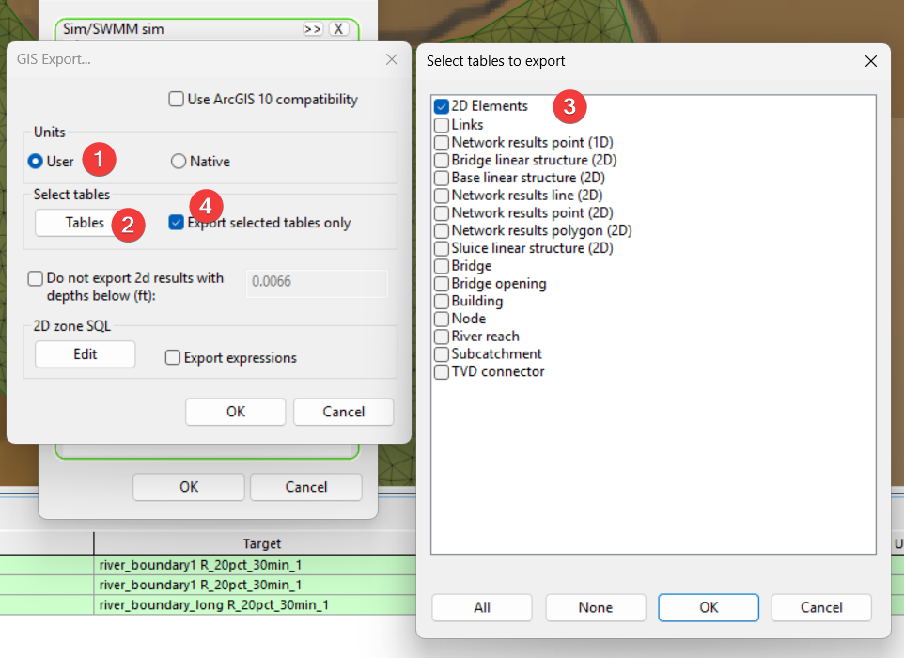

# Style 2D elements in QGIS

**Step 1: Load the DEM (Digital Elevation Model)**

1. Open QGIS and navigate to your **data folder**.
2. Drag the DEM file into the QGIS workspace.
3. Double-click the DEM layer → **Symbology** tab.
4. Change **Render type** to **Hillshade**.
5. For smoother visuals, set **Resampling** to **Bilinear**.

**Step 2: Add the 2D Model**

1. Load the shapefile for the full model into QGIS.
2. Confirm it covers the intended area.
3. Change the name to something more meaningful, go to **Layer Properties → Source** and set the correct model reference.

**Step 3: Style the 2D Zones**

1. In **Symbology**, choose **Graduated** style.
2. Set **Value** to Depth2D.
3. Select a **Blue color ramp** and click **Classify**.
4. Adjust **Transparency** to ~50% so the hillshade remains visible.
5. Click **Apply**.

**Step 4: Save the Style**

1. In the **Style** panel, click **Save Style**.
2. Save as a QGIS style file (*.qml) for reuse.
3. Ensure you only save **Symbology** settings.

**Step 5: Add Velocity Vectors**

1. Open **Processing Toolbox** → search for **Centroid**.
2. Run the **Centroid** tool on the full model layer.
3. Save as a new point layer (or temporary layer).
4. Rename the layer for clarity.

**Step 6: Apply Vector Field Styling**

1. Load a pre-defined style or create one:
   * Use **Vector Field Marker** for arrows.
   * Configure **Polar coordinate system** and **Radians** for direction.
2. Apply the style to visualize flow direction and velocity.

# Configure Elevation Properties for 2D Elements

For each 2D zone layer:

1. **Open Layer Properties → Elevation**
2. Set:
   * **Clamping**: *Clamp to Terrain*
   * **Offset Field**: GNDLV2D (ground level)
   * **Elevation Binding**: *Centroid*
3. **Enable Extrusion**:
   * Check the *Enable Extrusion* box.
   * For **Height**, use the *Depth2D* field (this represents water depth).

Repeat these steps for both scenario layers.

Offset:

Extrusion

# Use the Elevation Profile Tool

Once elevation properties are set:

1. Go to **View → Elevation Profile**.
2. In the toolbar, select **Capture Curve Tool** (polyline icon).
3. Draw a profile line across the area of interest.
4. The elevation profile will display:
   * **Bottom**: Ground elevation.
   * **Top**: Water surface elevation.
   * **Bar height**: Represents water depth (inverted bar chart style).

This visualization makes it easy to compare water levels and ground elevations between scenarios.

# Elevation Profile for Centroid

Using the centroid layer, you can plot continuous lines of the water surface instead of bars:

1. For the centroid layer:
   * Open **Layer Properties → Elevation**.
   * Set **Clamping** to *Clamped to Terrian*.
   * For **Offset**, use the water surface elevation field *elevation2*.
2. In the profile plot:
   * Change interpretation from *Individual Features* to *Continuous Surface* for a smooth line.
   * If left as *Individual Features*, points will display instead.

# Appendix

## Repo Structure

This directory contains a QGIS-based workflow for comparing 2D hydraulic modeling elements between a full model and a submodel, typically used for validating InfoWorks ICM 2D simulation outputs.

**Directory Structure**

2d_element_compare/

├── readme.docx # Documentation file

├── data/

│ ├── 2d elements comparison.qgz # QGIS project file

│ ├── dem_m01.asc # Digital Elevation Model

│ ├── style/ # QGIS symbology styles

│ │ ├── depth2d_blue_ramp_polygon.qml

│ │ ├── elevation_2d_element_centroid.qml

│ │ ├── elevation_2d_element_centroid_ws_line.qml

│ │ ├── elevation_2d_element_polygon.qml

│ │ ├── hillshade_for_dem.qml

│ │ └── max_velocity_arrow_point.qml

│ └── 2d_elements/

│ ├── full/ # Full model shapefiles

│ │ ├── 2D Zones.shp/.dbf/.shx/.prj

│ │ └── centroid.shp/.dbf/.shx/.prj/.cpg

│ └── submodel/ # Submodel shapefiles

│ ├── 2D Zones.shp/.dbf/.shx/.prj

│ └── centroid.shp/.dbf/.shx/.prj/.cpg

**File Descriptions**

**Root Level Files**

| **File** | **Description** |
| --- | --- |
| readme.docx | Documentation explaining the workflow and how to use the comparison tools. |

**data/ Directory**

| **File** | **Description** |
| --- | --- |
| 2d elements comparison.qgz | **QGIS Project File** – The main workspace that loads all layers (DEM, 2D zones, centroids) with pre-configured symbology for visual comparison of full model vs. submodel 2D elements. |
| dem_m01.asc | **Digital Elevation Model (DEM)** – An ESRI ASCII Grid raster file containing terrain elevation data. Grid specs: 1895 × 2137 cells, ~1.64m cell size, origin at (960584.81, 20267015.26), NODATA value of -9999. |

**data/style/ Directory (QGIS Style Files)**

| **File** | **Purpose** |
| --- | --- |
| depth2d_blue_ramp_polygon.qml | Graduated blue color ramp for 2D depth (DEPTH2D field) on polygon layers. Five classes ranging from 0.003m to 18.2m with quantile classification. |
| elevation_2d_element_centroid.qml | Elevation profile style for centroid points. Uses GNDLEV2D (ground level) as Z-offset and DEPTH2D for extrusion height. Orange line symbology. |
| elevation_2d_element_centroid_ws_line.qml | Water surface line profile style for centroids. Uses elevation2 field for Z-offset with DEPTH2D extrusion. Orange coloring for continuous surface display. |
| elevation_2d_element_polygon.qml | Elevation profile style for 2D zone polygons. Pink/magenta symbology with GNDLEV2D Z-offset and DEPTH2D extrusion for 3D profile visualization. |
| hillshade_for_dem.qml | Hillshade rendering style for the DEM raster. Azimuth: 315°, altitude angle: 45°, z-factor: 1. Creates terrain shading for better visualization. |
| max_velocity_arrow_point.qml | Vector field arrow symbology for velocity visualization. Uses SPEED2D for magnitude and MAXANGLE2D for direction. Displays arrows at centroid locations. |

**data/2d_elements/ Directory (Shapefiles)**

Two parallel sets of shapefiles exist for comparison:

**Full Model (full/)** – 2D elements from the complete hydraulic model.

**Submodel (submodel/)** – 2D elements from a smaller extracted portion of the model.